# Indian Bird Species Recognition Using Deep Learning

Submitted in partial fulfillment of the requirements of the degree

**BACHELOR OF ENGINEERING IN COMPUTER ENGINEERING**

By

**1. Yashneil Ballani (D12B/03)**

**2. Netal Bhansali(D12B/07)**

**3. Rashika Chandwani(D12B/08)**

**4. Bhanu Shamdasani(D12B/52)**

Name of the Mentor

**Prof.** Geocey Shejy



# Vivekanand Education Society’s Institute of Technology,

**An Autonomous Institute affiliated to University of Mumbai**

# HAMC, Collector’s Colony, Chembur,

**Mumbai-400074**

**University of Mumbai (AY 2023-24)**

# CERTIFICATE

This is to certify that the Mini Project entitled **“Indian Bird Species Recognition Using Deep Learning”** is a bonafide work of **Yashneil Ballani(03), Netal Bhansali(07), Rashika Chandwani(08), Bhanu Shamdasani(52)** submitted to the University of Mumbai in partial fulfillment of the requirement for the award of the degree of **“Bachelor of Engineering”** in **“Computer Engineering” .**

## (Prof.Geocey Shejy)

Mentor

## (Dr.Nupur Giri) (Dr. J M Nair)

Head of Department Prin

# Mini Project Approval

This Mini Project entitled “Indian Bird Species Recognition Using Deep Learning**”** by **Yashneil Ballani(03), Netal Bhansali(07), Rashika Chandwani(08), Bhanu Shamdasani(52)** is approved for the degree of **Bachelor of Engineering** in **Computer Engineering.**

**Examiners**

**1………………………………………**

(Internal Examiner Name & Sign)

## 2…………………………………………

(External Examiner name & Sign)

Date: Place:

**Declaration**

We declare that this written submission represents our ideas in our own words and where others' ideas or words have been included, we have adequately cited and referenced the original sources. We also declare that we have adhered to all principles of academic honesty and integrity and have not misrepresented or fabricated or falsified any idea/data/fact/source in our submission. We understand that any violation of the above will be cause for disciplinary action by the Institute and can also evoke penal action from the sources which have thus not been properly cited or from whom proper permission has not been taken when needed.

----------------------------------------- -----------------------------------------

(Yashneil Ballani - 03) (Netal Bhansali - 07)

----------------------------------------- -----------------------------------------

(Rashika Chandwani - 08) (Bhanu Shamdasani - 52)

Date: 30/03/2024

**Acknowledgement**

We would like to express our sincere gratitude towards the head of the Computer Department **Dr (Mrs) Nupur Giri**. Also, we earnestly acknowledge and are grateful for the sincere efforts and valuable time given to us by our mentor **Mrs Geocey Shejy** of the Computer Department. We also are greatly obliged for the advice and guidance we received from the faculty of **Computer Science and Engineering Department**.

# Contents

## Acknowledgments i

## List of Abbreviations ii

## List of Figures iii

**List of Tables vi**

**Abstract**   **v**

**Chapter 1: Introduction**

1.1 Introduction

1.2 Motivation

1.3 Problem Definition

1.4 Existing Systems

1.5 Lacuna of the existing systems

1.6 Relevance of the Project

**Chapter 2: Literature Survey**

A. Brief Overview of Literature Survey

B. Related Works

2.1 Research Papers Referred

a. Abstract of the research paper

b. Inference drawn

2.2 Comparison with the existing system

**Chapter 3: Requirement Gathering for the Proposed System**

3.1 Introduction to requirement gathering

3.2 Functional Requirements

3.3 Non-Functional Requirements

3.4.Hardware, Software , Technology and tools utilized

3.5 Constraints

**Chapter** 4**: Proposed Design**

4.1 Block diagram of the system

4.2 Modular design of the system

4.3 Detailed Design

4.4 Project Scheduling & Tracking using Timeline / Gantt Chart

**Chapter 5: Implementation of the Proposed System**

5.1. Methodology employed for development

5.2 Algorithms and flowcharts for the respective modules developed

5.3 Datasets source and utilization

**Chapter 6: Testing of the Proposed System**

6.1. Introduction to testing

6.2. Types of tests Considered

6.3 Various test case scenarios considered

6.4. Inference drawn from the test cases

**Chapter 7: Results and Discussion**

7.1. Performance Evaluation measures

7.2. Input Parameters / Features considered

7.3. Graphical and statistical output

7.4. Comparison of results with existing systems

7.5. Inference drawn

**Chapter 8: Conclusion**

8.1 Limitations

8.2 Conclusion

8.3 Future Scope

**References**

**List of Abbreviations**

| **Abbreviation** | **Expansion** |
| --- | --- |
| RNN | Recurrent neural network |
| CNN | Convolutional neural network |
| MFCC | Mel-frequency cepstral coefficients |
| CPU | Central processing unit |
| GPU | Graphics processing unit |
| RAM | Random-access memory |
| IDE | Integrated Development Environment |

## List of Figures

| Fig 1 | Block Diagram |
| --- | --- |
| Fig 2 | Modular Diagram |
| Fig 3 | Audio Preprocessing Module Flowchart |
| Fig 4 | Deep Learning Model Training Module Flowchart |
| Fig 5 | Bird Species Classification Module Flowchart |

## 

## 

## 

## 

## 

## 

## 

## 

## 

**List of Tables**

| Table 1 | Comparison with the existing system |
| --- | --- |

**Abstract**

With the increasing availability of audio recording devices and the advancement of deep learning techniques, automatic bird voice recognition has emerged as an effective tool to identify bird species based on their distinct vocalizations. This abstract is an overview of a novel approach to recognize bird species using bird voice recognition in combination with deep learning algorithms.

The proposed system begins by collecting Indian specific audio recordings of bird vocalizations in various natural habitats. These audio samples are pre-processed to remove background noise, normalize the audio levels, and extract relevant acoustic features, such as pitch, amplitude, and frequency modulation. The resulting feature vectors serve as inputs to the deep learning model.

**1. INTRODUCTION**

**1.1 Introduction**

Birds serve as vital components of our ecosystems, playing pivotal roles in maintaining ecological balance and enhancing biodiversity. Their presence and behavior offer valuable insights into the overall health of these intricate systems. Understanding bird populations is essential for assessing and responding to the dynamic changes in environmental conditions and, in turn, for effectively advancing conservation efforts.

One of the primary methods employed in the identification and monitoring of bird species hinges on their vocalizations. Birds communicate through unique and distinguishable calls, songs, and chirps. This acoustic diversity among species enables ornithologists and ecologists to pinpoint avian presence, even in challenging scenarios where visual identification is impractical, such as densely vegetated areas or remote locations.

In recent years, a confluence of technological advances has revolutionized the study of birds. Notably, enhancements in audio recording technology have equipped researchers with the tools to capture high-quality soundscapes. Coupled with this, the burgeoning availability of data resources has paved the way for the application of deep learning techniques in bird species recognition.

Deep learning's integration into bird species recognition represents a transformative step forward. Deep learning models are adept at recognizing and classifying bird vocalizations with remarkable accuracy. They can distinguish subtle distinctions among bird calls, even among closely related species. This innovation provides the means to efficiently and accurately identify the species present in vast audio datasets.

The use of deep learning and bird species recognition has opened exciting new horizons for avian population monitoring. It enables researchers to conduct large-scale, long-term studies, collecting extensive audio data from a multitude of habitats and geographical regions. This wealth of information contributes to a nuanced and comprehensive understanding of bird populations, their distribution, and their responses to environmental fluctuations.

**1.2 Motivation**

**Conservation Efforts:** By developing a deep learning-based bird voice recognition system, you have the power to make a real difference in the conservation of our avian friends. This project can aid ornithologists and conservationists in monitoring and protecting bird populations, providing valuable insights into their behavior and habitats.

**Biodiversity Preservation:** Birdsong is not just beautiful; it's a key indicator of biodiversity. This project can contribute to preserving the rich tapestry of species that enrich our ecosystems. By understanding bird vocalizations, we can better protect their habitats and prevent further species loss.

**Education and Awareness:** This work can inspire a new generation of nature enthusiasts and environmental advocates. Bird voice recognition can serve as an educational tool, raising awareness about the importance of birds in our ecosystems and fostering a sense of stewardship for our natural world.

**Scientific Discovery:** Deep learning technology has the potential to reveal hidden patterns in bird vocalizations that the human ear may not detect. This can lead to groundbreaking scientific discoveries about bird behavior, communication, and adaptation to environmental changes.

**Impact on Technology:** Bird voice recognition is a relatively unexplored field, and your project can push the boundaries of what deep learning can achieve. This system may have applications beyond ornithology, influencing various fields such as speech recognition and audio analysis.

**Connecting with a Community:** The community of birdwatchers, conservationists, and technologists is vibrant and passionate. Your project can help you connect with like-minded individuals who share your enthusiasm for birds and cutting-edge technology.

**1.3 Problem Statement & Objectives**

The central focus of this project revolves around the development of robust deep learning models with the capacity to accurately classify and identify different bird species based on their vocalizations. However, this presents a multifaceted set of challenges. Foremost among these challenges is the creation of a comprehensive and diverse dataset that encompasses the extensive array of bird species and their vocalizations. Additionally, bird vocalizations can be influenced by various environmental factors, introducing complexities due to background noise, making the task intricate.

The core challenge lies in the development of deep learning models that are not only reliable but also robust. These models should be adept at accurately classifying and identifying bird species despite the presence of noisy data, variations in vocalizations among individual birds, and the nuances of distinguishing between closely related species. Moreover, the project is intrinsically tied to the crucial objective of contributing to the conservation of endangered bird species. This involves the vital task of detecting and reporting the presence of these endangered species through their vocalizations to enable timely interventions and protection.

To achieve this overarching objective, the project lays out a multifaceted plan. First, the creation of reliable deep learning models takes center stage. These models should exhibit a high degree of accuracy even when confronted with the complex and diverse vocalizations of avian species. Equally important is the development of a comprehensive and diverse dataset, one that encapsulates the various species and the intricacies of their vocalizations in different environmental settings.

The application of this technology extends beyond research into the real world of conservation. The project seeks to deploy these deep learning models in the field for practical, real-time monitoring and reporting. By doing so, it enhances the capacity of conservationists to safeguard bird species facing the imminent threat of extinction, marking a meaningful and impactful step towards ecological preservation and protection. In summary, this project unites the realms of technology and ecology in a concerted effort to address a multifaceted problem, simultaneously advancing our understanding of avian vocalizations and contributing to the critical cause of conserving endangered bird species.

**1.4 Existing Systems**

While numerous organizations and initiatives in India focus on aspects related to bird classification and monitoring, it's notable that they typically do not utilize deep learning algorithms, distinguishing them from the proposed project. These existing endeavors predominantly rely on traditional methodologies, such as visual identification, field surveys, and citizen science participation. Below are some examples of such projects and organizations, along with a brief comparison highlighting the differences:

**eBird India:**

Methodology: eBird primarily relies on citizen science contributions for bird observations, where users submit their sightings through a web platform.

Differentiation: While eBird serves as a valuable tool for recording bird sightings, it predominantly relies on manual data input and visual identification by users, rather than employing automated deep learning algorithms for species classification based on sound.

**Indian Bird Conservation Network (IBCN):**

Activities: IBCN facilitates collaborative efforts among organizations and individuals for bird conservation through research, monitoring, and advocacy.

Differentiation: While IBCN contributes significantly to bird conservation efforts in India, its activities typically focus on broader conservation initiatives, such as habitat protection and community engagement, rather than developing technological solutions for automated species classification using deep learning algorithms.

**Salim Ali Centre for Ornithology and Natural History (SACON):**

Research Focus: SACON conducts research on various aspects of bird ecology, behavior, and conservation.

Differentiation: SACON's research encompasses a wide range of methodologies, including field surveys and ecological studies, but may not specifically emphasize the development and implementation of advanced technologies like deep learning algorithms for bird sound classification.

While these organizations and projects contribute significantly to avian research and conservation in India, the proposed project stands out for its innovative approach, leveraging deep learning algorithms for automated bird species classification based on sound signatures. By employing cutting-edge technology, the project aims to enhance the efficiency and accuracy of bird monitoring efforts, thereby complementing the existing initiatives and advancing the field of ornithology in India.

**1.5 Lacuna of the existing systems**

**Species Coverage:** Existing systems may lack comprehensive coverage of bird species, especially when it comes to uncommon or diversified species. Models trained on data primarily from popular or well-documented species may struggle to accurately identify less common or region-specific birds. This limitation can undermine the utility of the system in areas with diverse avian populations, such as India.

**Noise Challenges:** Background noise can interfere with the detection and recognition of bird vocalizations, especially in urban or noisy environments. Systems need to be robust enough to filter out irrelevant noise while preserving the bird sounds of interest. This might involve preprocessing techniques such as noise reduction, adaptive filtering, or sophisticated machine learning algorithms trained to distinguish between bird calls and background noise.

**Variability in Habitats:** Birds inhabit a wide range of environments, from dense forests to urban areas, each with its own acoustic characteristics. Existing systems may struggle to adapt to this variability in habitats, leading to decreased performance in certain environments. Evaluating and improving a model's adaptation to various habitats is crucial for ensuring its effectiveness across different geographic regions and ecosystems.

**Real-time Constraints:** Many existing bird voice recognition systems may not be optimized for real-time applications, where low latency and high throughput are essential. Achieving real-time performance requires efficient model architectures, optimized inference algorithms, and potentially hardware acceleration. Balancing accuracy with speed is essential to meet the demands of real-time bird monitoring applications.

**Ethical Considerations:** Privacy issues and ethical considerations are paramount, especially in applications where audio recordings are collected from natural environments. Existing systems may not adequately address these concerns, raising questions about data privacy, consent, and potential harm to bird populations. Implementing robust data anonymization techniques, obtaining consent when necessary, and adhering to ethical guidelines are crucial for responsible deployment of bird voice recognition systems.

**Data Accessibility:** Accessibility to labeled bird sound datasets can be a significant challenge for researchers and developers, especially concerning fair data management and access. Existing datasets may be limited in size, scope, or diversity, hindering the development of more accurate and inclusive bird voice recognition systems. Promoting open access to bird sound datasets and fostering collaboration within the research community can help address this challenge.

**1.6 Relevance of the Project**

Bird sound classification using deep learning algorithms represents a significant advancement in the field of ornithology and conservation biology, offering a transformative approach to species identification and ecological monitoring. This section elucidates the relevance of the project within the broader scientific and environmental contexts, emphasizing its implications for biodiversity conservation, ecological research, and technological innovation.

**Advancing Biodiversity Conservation:** The project's relevance is underscored by its potential to revolutionize biodiversity monitoring efforts. As habitats face unprecedented threats from human activities, the need for efficient and accurate monitoring tools has never been more pressing.

**Empowering Ecological Research:** In addition to its conservation applications, the project holds significant relevance for ecological research. Bird vocalizations serve as key indicators of ecological processes, including breeding behavior, species interactions, and habitat quality.

**Driving Technological Innovation:** Furthermore, the project's relevance extends to the realm of technological innovation. Deep learning algorithms represent a cutting-edge approach to pattern recognition and classification, with applications across various domains.

The relevance of the project lies in its ability to address critical challenges in biodiversity conservation, ecological research, and technological innovation. By harnessing the power of deep learning algorithms for bird sound classification, the project offers a promising solution to the pressing need for efficient and accurate monitoring tools in ornithology and conservation biology.

**2. LITERATURE SURVEY**

**A. Brief Overview of Literature Survey**

The literature survey explored the application of deep learning techniques for bird audio classification, focusing on Convolutional Neural Networks (CNNs) and Recurrent Neural Networks (RNNs). These architectures have demonstrated success in recognizing bird calls due to their ability to learn complex patterns from audio data. The reviewed papers highlighted the effectiveness of CNNs in extracting features from spectrograms, visual representations of sound frequencies, for bird species classification. However, limitations were identified, such as model complexity for a large number of bird species and challenges in capturing long-range dependencies in bird calls, which RNNs might be better suited for.

**B. Related Works**

**2.1 Research Papers Referred**

**a. Bird Species Identification using Deep Learning (Prof. Pralhad Gavali et al., 2019)**

Abstract: The researchers propose employing deep residual neural networks to recognize bird species from audio recordings, presenting a more efficient alternative to manual tracking methods. By harnessing advanced techniques like data augmentation and curated datasets, such as those from Neural Information Processing Scaled for Bioacoustics, they aim to enhance ecologists' ability to monitor environmental impacts on bird populations effectively.

Inference Drawn: While RNNs offer advantages, the paper acknowledges their limitations in capturing long-range dependencies within bird calls. This suggests exploring architectures that can effectively address this challenge for Indian bird species recognition.

**b. A review of automatic recognition technology for bird vocalizations in the deep learning era (Xie Jiangjian et al., 2022)**

Abstract: This review paper discusses the potential of automatic bird call recognition in aiding bird population monitoring and conservation efforts. This review covers DL-based methods, including pre-processing, feature extraction, and recognition techniques, along with related datasets and challenges. It emphasizes the role of deep learning in achieving accurate classification.

Inference Drawn: This paper aligns with the project's goal of using deep learning for bird species recognition. It highlights the ecological significance of such a system for bird conservation in India.

**c. Bird Sound Recognition Using a Convolutional Neural Network(CNN) (A. Incze et al., 2018)**

Abstract: This paper explores CNNs for bird sound classification, emphasizing benefits for nature enthusiasts and ornithologists. The system was tested using different configurations and settings. The results showed that the system worked best when the color map chosen was similar to the images the network was trained on. It uses transfer learning with MobileNet and spectrograms from audio data.

Inference Drawn: This paper showcases the feasibility of CNNs for bird call recognition. However, the limitation of a smaller bird species dataset suggests the need for exploring approaches that can handle the wider variety of bird calls found in India.

**d. A novel deep transfer learning models for recognition of birds sounds in different environment (Y. Kumar et al., 2022)**

Abstract: Proposes a novel approach using deep transfer learning models to identify bird sounds across various environments. This method leverages pre-trained models on similar tasks to improve accuracy and handle background noise or variations in bird calls that can occur in different habitats. This research suggests promise for real-world applications where bird call recognition needs to be robust to diverse environmental conditions.

Inference Drawn: This paper explores transfer learning, a technique for leveraging pre-trained models on similar tasks, for bird call recognition. This approach could be valuable for our project, considering the limited availability of large datasets specifically for Indian birds. However, the limitation of offline processing highlights the need to explore real-time application capabilities for a more user-friendly bird recognition system.

**2.2 Comparison with the existing system**

| **Aspect** | **Proposed System** | **Bird Species Identification using Deep Learning** | **A Review of Automatic Recognition Technology for Bird Vocalizations** | **A Novel Deep Transfer Learning Models for Recognition of Bird Sounds** |
| --- | --- | --- | --- | --- |
| Methodology | Convolutional Neural Networks (CNNs), data augmentation, curated datasets | Deep residual neural networks, data augmentation | Deep learning-based methods for automatic bird call recognition | Transfer learning models, pre-trained models |
| Focus | Bird species recognition from audio recordings | Bird species recognition from audio recordings | Automatic recognition technology for bird vocalizations | Bird sound recognition across various environments |
| Strengths | Utilizes advanced deep learning techniques, focuses on Indian bird species | Incorporates advanced techniques, curated datasets | Provides comprehensive overview, emphasizes ecological significance | Addresses robustness against background noise, variations in bird calls |
| Limitations | Acknowledges RNN limitations, aims to explore alternative architectures | Acknowledges RNN limitations | Focuses on challenges, lacks specific solutions for Indian context | Offline processing, lacks real-time capabilities |
| Contributions | Contributes to bird conservation efforts in India | Enhances accuracy, explores alternative architectures | Provides insights into challenges, opportunities in bird call recognition | Enhances robustness against environmental variations, background noise |
| Future Directions | Address real-time application capabilities, scalability issues | Explore alternative architectures, improve dataset coverage | Develop tailored solutions for Indian context, address limitations | Investigate real-time application, scalability, dataset expansion |

**Table 1 : Comparison with the existing system**

**3. Requirement Gathering for the Proposed System**

**3.1 Introduction to requirement gathering**

In order to develop an accurate and comprehensive Indian bird sound recognition system, the initial step involves gathering a diverse and extensive dataset of bird vocalizations. This requires a systematic approach to sourcing data from various websites and organizations specializing in avian research and conservation efforts.

**Identifying Potential Data Sources:** The first stage of requirement gathering involves researching and identifying potential websites and organizations that host repositories of Indian bird vocalizations. This includes platforms dedicated to birdwatching, ornithological societies, research institutions, and conservation groups.

**Contacting Data Providers:** Once potential data sources have been identified, proactive outreach is conducted to establish communication with these organizations. This involves sending inquiries via email or other appropriate channels, expressing interest in accessing their bird sound datasets for research purposes.

**Establishing Collaboration:** Upon receiving responses from data providers who are willing to collaborate, further communication is initiated to establish the terms of collaboration. This includes discussing data sharing agreements, licensing terms, and any specific requirements or restrictions associated with accessing and using the data.

**Data Acquisition**: After reaching agreements with data providers, the process of data acquisition begins. This involves collecting bird sound files corresponding to species native to India, as well as relevant metadata such as species names, recording locations, and timestamps.

**Supplementing with Online Resources:** In addition to collaborating with specific organizations, efforts are made to supplement the dataset by collecting bird sound files from other online sources. This may include publicly available databases, citizen science projects, and academic repositories.

**Documentation and Organization:** Finally, proper documentation and organization of the collected data are essential. This includes maintaining detailed records of the source of each recording, associated metadata, and any relevant information pertaining to data usage rights and permissions.

By following this systematic approach to requirement gathering for data collection, the Indian bird sound recognition system can be built upon a robust and comprehensive dataset, facilitating the development of accurate and reliable machine learning models for species identification and conservation efforts.

**3.2 Functional Requirements**

**Audio Input Processing:**

The system must be able to process audio inputs in various formats commonly used for bird sound recordings (e.g., WAV, MP3).

It should support audio inputs of varying lengths to accommodate different durations of bird vocalizations.

**Feature Extraction:**

The system should extract relevant features from the audio inputs, such as Mel-Frequency Cepstral Coefficients (MFCCs), spectrograms, or other time-frequency representations.

Feature extraction should be performed efficiently to minimize computational overhead.

**Deep Learning Model Integration:**

The system must integrate deep learning models capable of learning representations from the extracted audio features.

It should support different types of deep learning architectures suitable for audio classification tasks, such as Convolutional Neural Networks (CNNs), recurrent neural networks (RNNs), or their combinations (e.g., CNN-RNN hybrids).

**Training and Evaluation:**

The system should provide functionality for training deep learning models using labeled bird sound datasets.

It must support evaluation of trained models using standard metrics such as accuracy, precision, recall, and F1-score.

Cross-validation techniques should be employed to assess model generalization performance.

**Classification Output:**

The system should output predictions of bird species based on the input audio, along with confidence scores or probabilities for each predicted class.

**3.3 Non-Functional Requirements**

**Accuracy and Performance:**

The system should achieve high accuracy in bird species classification, with performance benchmarks established based on state-of-the-art approaches.

It must be capable of processing audio inputs efficiently to provide timely classification results, especially for real-time applications.

**Scalability:**

The system should be scalable to handle large volumes of audio data and accommodate increasing demands as the dataset grows.

It should leverage distributed computing resources effectively for parallel processing and training of deep learning models.

**Robustness to Noise and Variability:**

The system must be robust to variations in background noise levels and environmental conditions commonly encountered in natural habitats.

It should exhibit resilience to variations in bird vocalizations due to factors such as distance, direction, and overlapping sounds from multiple bird species.

**Usability and Accessibility:**

The system should have a user-friendly interface for researchers, conservationists, and citizen scientists to interact with.

It should provide documentation and tutorials to facilitate usage by individuals with varying levels of technical expertise.

**Ethical Considerations:**

The system should adhere to ethical guidelines regarding data privacy, consent, and responsible use of bird sound recordings.

It must respect intellectual property rights associated with the use of third-party datasets and ensure proper attribution where required.

**3.4.Hardware, Software , Technology and tools utilized**

**Hardware:**

CPU and GPU: Utilize high-performance CPUs and GPUs for efficient processing and training.

RAM and Storage: Ensure sufficient RAM and storage capacity for data handling and model storage.

**Software:**

Deep Learning Frameworks: Employ TensorFlow, PyTorch, or Keras for building and training models.

Python: Utilize Python for its extensive libraries and ecosystem.

Audio Processing Libraries: Use LibROSA or PyDub for audio preprocessing.

Data Management Tools: Employ pandas for organizing and analyzing datasets.

Development Environments: Use Jupyter Notebook or PyCharm for coding and debugging.

Version Control: Utilize Git for code management and collaboration.

**Technology:**

Deep Learning Architectures: Implement CNNs, RNNs, and transfer learning techniques.

Real-Time Processing: Use WebRTC and TensorFlow Lite for real-time audio processing.

Parallel Computing: Employ TensorFlow Distributed or Horovod for distributed training.

**Tools:**

TensorFlow: For flexibility and scalability in deep learning.

LibROSA: Provides audio analysis functionalities.

Keras: User-friendly interface for building models.

Scikit-learn: Offers machine learning algorithms and tools.

**3.5 Constraints**

**Data Availability:** Limited availability of labeled bird sound datasets, especially for diverse or rare species, can constrain model training and generalization.

**Real-World Variability:** Variability in bird vocalizations due to factors such as background noise, environmental conditions, and individual bird behaviors can challenge model robustness and accuracy.

**Ethical Considerations:** Ethical considerations regarding data privacy, consent, and responsible use of bird sound recordings must be addressed to ensure compliance with ethical guidelines and regulations.

**Evaluation Metrics:** Choosing appropriate evaluation metrics to assess model performance accurately in the context of bird classification can be challenging, especially considering the multi-class nature of the problem and potential class imbalances.

**Generalization:** Ensuring model generalization across different geographical regions, habitats, and recording conditions is crucial for real-world deployment but may be challenging due to variations in bird species and environments.

**4. Proposed Design**

**4.1 Block diagram of the system**

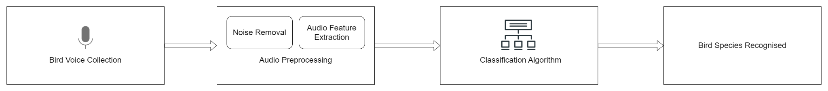

**Fig 1: Block Diagram**

**Bird voice collection:** The first step is to collect a large collection of bird voices from different species. This can be done by recording bird calls in the wild or by using existing datasets of bird recordings.

**Audio preprocessing:** Once the bird voices have been collected, they need to be cleaned up and normalized. This involves removing noise and other artifacts, such as background noise and echoes. The audio may also need to be normalized to ensure that all of the recordings have the same volume level.

**Audio feature extraction:** Once the audio recordings have been preprocessed, a variety of features can be extracted from them. These features can include pitch, duration, spectral energy, and other acoustic properties. The extracted features will be used by the classification algorithm to identify the bird species.

**Classification algorithm:** A machine learning algorithm is trained on the extracted features and the corresponding bird species labels. The algorithm learns to associate the features with the bird species labels. Once the algorithm is trained, it can be used to identify the bird species in new audio recordings.

**Bird species recognized:** The trained classification algorithm is used to recognize the bird species in new audio recordings. The algorithm takes the extracted features from the new audio recording and predicts the bird species.

**4.2 Modular design of the system**

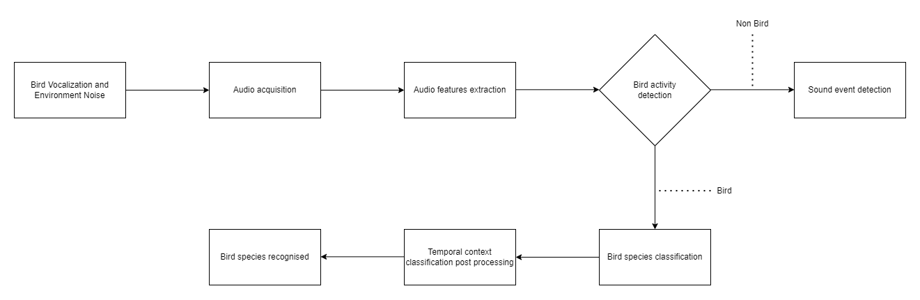

**Fig 2: Modular Diagram**

**Audio acquisition:** The first step is to record the bird vocalizations. This can be done using a microphone or a recorder. It is important to record the bird vocalizations in a quiet environment to minimize background noise.

**Audio preprocessing:** Once the bird vocalizations have been recorded, they need to be cleaned up and normalized. This involves removing noise and other artifacts, such as background noise and echoes. The audio may also need to be normalized to ensure that all of the recordings have the same volume level.

**Feature extraction:** After audio preprocessing, various features like pitch, duration, spectral energy, and more are extracted. These features are utilized by the classification algorithm to identify the bird species.

**Bird species classification:** A machine learning algorithm is used to classify the bird species based on the extracted features. The algorithm learns to associate the features with the bird species labels. Once the algorithm is trained, it can be used to identify the bird species in new audio recordings.

**Bird species recognized:** The output of the bird species classification algorithm is the predicted bird species. This information can be used to identify the bird species in the audio recording.

**4.3 Detailed Design**

**Audio Preprocessing:**

Audio preprocessing is crucial for enhancing the quality and consistency of the input data before feeding it into the deep learning model. Techniques commonly employed in audio preprocessing include:

1. Noise Reduction: Various noise reduction algorithms, such as spectral subtraction or adaptive filtering, can be used to suppress background noise and improve the signal-to-noise ratio of the audio recordings.
2. Segmentation: Audio recordings may contain multiple bird vocalizations or background sounds. Segmenting the recordings into individual vocalizations or segments of interest facilitates more accurate feature extraction and classification.
3. Normalization: Normalizing the amplitude or intensity of audio signals ensures uniformity across recordings, preventing biases in feature extraction and model training caused by variations in volume levels.

**Feature Extraction:**

Feature extraction involves extracting relevant acoustic features from preprocessed audio signals, which serve as input to the deep learning model. Commonly used features for bird sound classification include:

1. Mel-Frequency Cepstral Coefficients (MFCCs): MFCCs represent the short-term power spectrum of audio signals, capturing frequency characteristics similar to human auditory perception.
2. Spectrograms: Spectrograms provide a visual representation of the frequency content of audio signals over time, enabling the extraction of temporal and spectral features.

**Deep Learning Model Architecture:**

The architecture and configuration of the deep learning model play a crucial role in determining its effectiveness in classifying bird species. Various architectures can be explored, such as -

Convolutional Neural Networks (CNNs):

Convolutional Neural Networks (CNNs) have demonstrated remarkable success in various tasks involving spatial data, including image classification, object detection, and speech recognition. In the context of bird sound classification, CNNs are particularly well-suited for learning spatial hierarchies of features from spectrogram-based input data.

**Training Procedure:**

The training procedure involves training the deep learning models using labeled bird sound datasets. Key steps in the training procedure include:

1. Hyperparameter Tuning: Tuning hyperparameters such as learning rate, batch size, and regularization parameters to optimize model performance and prevent overfitting.
2. Model Evaluation: Evaluating the trained models using validation datasets and monitoring performance metrics such as accuracy, precision, recall, and F1-score. Fine-tuning the models based on evaluation results to achieve the desired classification performance.

**4.4 Project Scheduling & Tracking using Timeline / Gantt Chart**

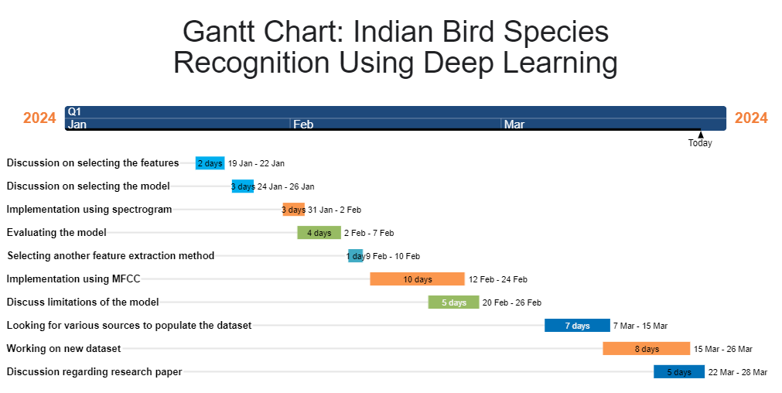

**5. Implementation of the Proposed System**

**5.1. Methodology employed for development**

In this project, each step plays a crucial role in advancing our capabilities for bird species recognition and conservation.

The process begins with the collection of bird audio recordings from various settings, reflecting the diverse natural habitats where these avian species thrive. By capturing these vocalizations in different environmental conditions and geographic regions, the dataset becomes more comprehensive and representative of real-world scenarios. This extensive data collection is essential for developing a deep learning model that can generalize across various contexts.

The next phase focuses on enhancing the quality of the audio recordings. This step is indispensable as it separates the valuable bird vocalizations from background noise, which can often be quite challenging in field recordings. By isolating the key sound components, the dataset becomes more informative and suitable for training a deep learning model. Removing noise and preprocessing the data is a meticulous task that requires advanced audio signal processing techniques and tools.

The heart of the project revolves around the development of a specialized deep learning model for bird species identification. This model is designed to recognize patterns and features within bird vocalizations that are unique to each species. It is trained on the enhanced dataset, learning to distinguish between the subtle variations in calls, songs, and chirps that differentiate one bird species from another. The deep learning model's capacity for this nuanced classification is a result of extensive training and fine-tuning, where it learns to discern even the most subtle distinctions.

After the model is trained, the critical phase of performance assessment follows. This step ensures that the deep learning model can accurately identify bird species with a high degree of confidence. The model's performance is evaluated on various metrics such as accuracy, precision, recall, and specificity, providing insights into its capabilities and areas for improvement. Continuous iterations and further adjustments are made as needed to enhance result accuracy.

Moreover, the project is open to incorporating additional procedures or techniques that may arise during the evaluation phase. These could include post-processing methods to smoothen predictions, addressing challenges such as overlapping vocalizations from multiple species, and extending the model's generalization capabilities across diverse habitats. The project's iterative nature allows for a dynamic and adaptable approach, ensuring that the final deep learning model is as robust and accurate as possible.

In sum, this comprehensive endeavor represents the synergy of technological innovation, ecological research, and data-driven insights. It holds the potential to revolutionize our understanding of bird populations, their vocalizations, and their habitats. By accurately identifying bird species through deep learning, this project contributes to the preservation of avian biodiversity and the advancement of ornithological research.

**5.2 Algorithms and flowcharts for the respective modules developed**

**Audio Preprocessing Module:**

The Audio Preprocessing Module is responsible for preparing the raw bird sound recordings for input into the deep learning model. It involves converting the audio files into a suitable format, reducing noise, and extracting relevant features using Mel-Frequency Cepstral Coefficients (MFCCs) and spectrograms.

Using MFCC:

Using Mel-Frequency Cepstral Coefficients (MFCCs), the audio preprocessing module captures sound frequency characteristics akin to human auditory perception. This involves segmenting the audio into short frames, typically lasting 20-40 milliseconds, followed by the application of a windowing function. Utilizing the Fast Fourier Transform (FFT), each frame transitions from the time domain to the frequency domain. Subsequently, a power spectrum is computed, and a filterbank, mirroring human auditory resolution, is applied. Finally, the logarithm of the filterbank energies undergoes a Discrete Cosine Transform (DCT), yielding the MFCC coefficients.

Using Spectrogram :

Use of spectrograms in preprocessing provides a visual representation of the signal's frequency spectrum over time. This 2D depiction offers insights into the audio's frequency content evolution. The process entails dividing the audio signal into short-time windows, computing the Fourier Transform for each window, and plotting the magnitude of the resulting spectrum against time, thereby constructing the spectrogram.

Algorithm:

1. Input: Bird sound recordings in audio format.
2. Convert the audio files to a suitable format for analysis (e.g., WAV).
3. Apply preprocessing techniques such as noise reduction, filtering, and segmentation to enhance the quality of the audio signals.
4. Extract relevant features from the preprocessed audio data, such as Mel-Frequency Cepstral Coefficients (MFCCs) or spectrograms.
5. Output: Preprocessed audio data with extracted features.

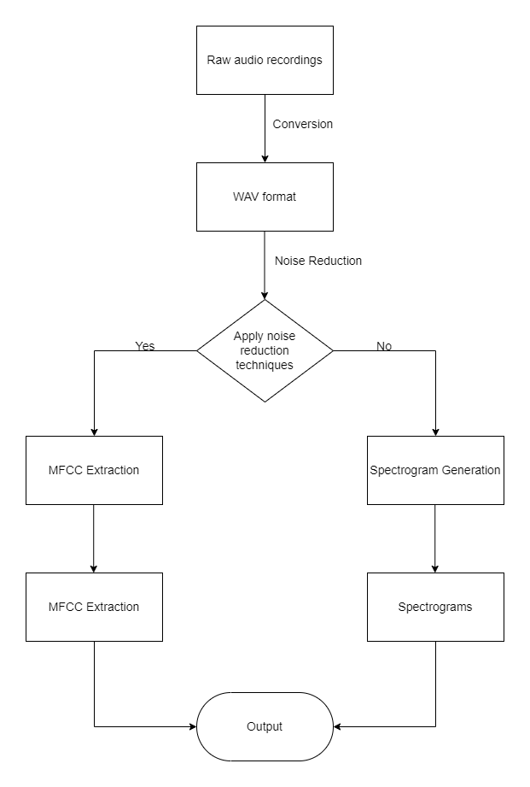

**Fig 3: Audio Preprocessing Module Flowchart**

**Deep Learning Model Training Module:**

The Deep Learning Model Training Module is responsible for training a Convolutional Neural Network (CNN) model on the preprocessed audio data to learn features and classify bird species.

CNNs are well-suited for audio classification due to their ability to automatically learn hierarchical representations from raw data. They can extract discriminative features directly from spectrograms or other time-frequency representations. Typically, a CNN architecture consists of convolutional layers for feature extraction, followed by max-pooling layers for dimensionality reduction, and fully connected layers for classification. This enables CNNs to effectively capture spatial features across different frequencies and make accurate predictions about the classes of input audio samples.

Algorithm:

1. Input: Preprocessed audio data with extracted features and corresponding labels (bird species).
2. Split the dataset into training, validation, and testing sets.
3. Choose a deep learning architecture suitable for audio classification tasks (e.g., Convolutional Neural Network).
4. Initialize the model parameters and define the loss function (e.g., categorical cross-entropy).
5. Train the deep learning model using the training data, optimizing the model parameters through backpropagation and gradient descent.
6. Validate the trained model using the validation set to monitor performance and prevent overfitting.
7. Evaluate the final model's performance on the testing set using appropriate metrics (e.g., accuracy, precision, recall).
8. Output: Trained deep learning model for bird species classification.

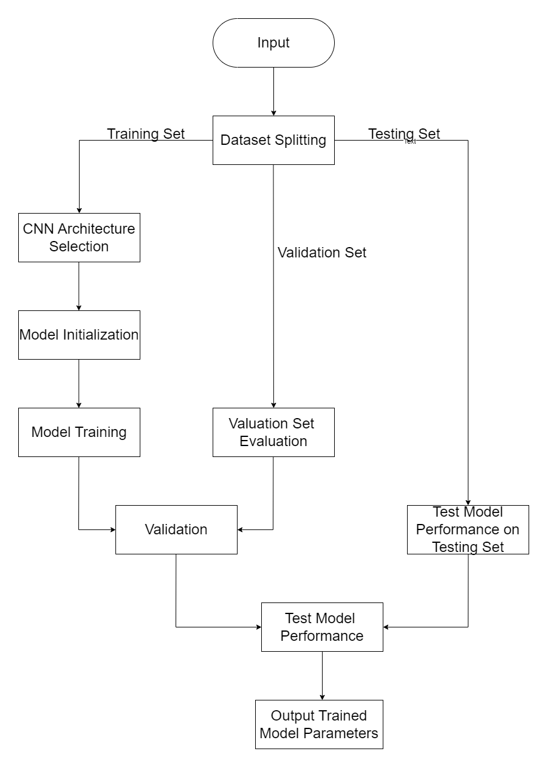

**Fig 4: Deep Learning Model Training Module Flowchart**

**Bird Species Classification Module:**

The Bird Species Classification Module utilizes the trained CNN model to classify unlabeled bird sound recordings into different bird species.

Algorithm:

1. Input: Unlabeled bird sound recordings in audio format.
2. Preprocess the audio data and extract relevant features as in the preprocessing module.
3. Input the preprocessed audio data into the trained deep learning model.
4. Use the model to predict the bird species for each input audio sample based on the extracted features.
5. Output: Predicted bird species labels for the input audio recordings.

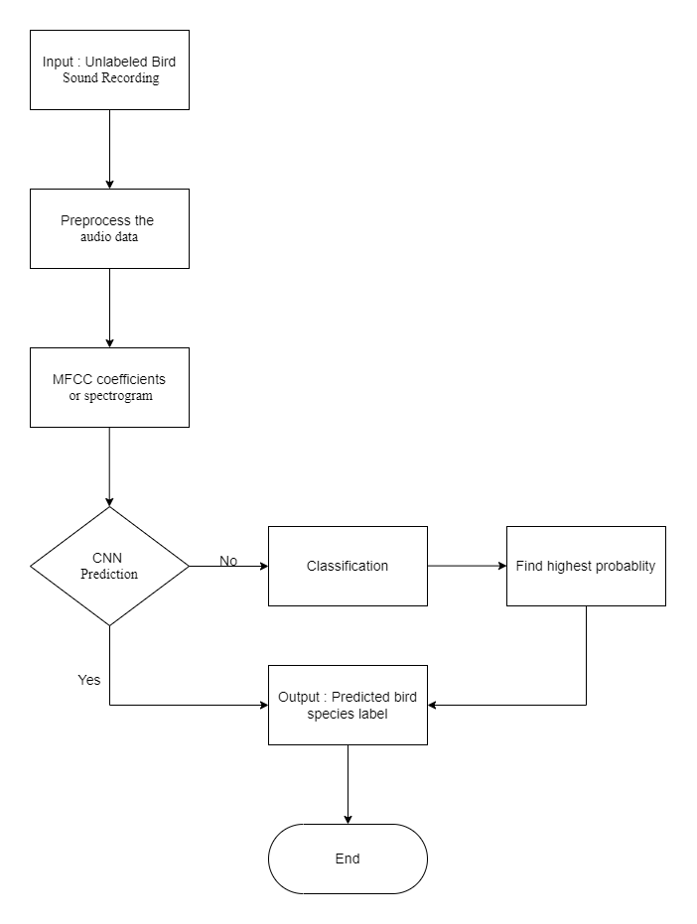

**Fig 5:Bird Species Classification Module Flowchart**

**5.3 Datasets source and utilization**

The success of the bird classification system heavily relies on the availability and quality of the datasets utilized for training, validation, and testing purposes. The datasets used in this project are sourced from various reputable sources, including:

**Online Repositories:** Publicly available online repositories dedicated to bird sound recordings, such as Xeno-canto and Macaulay Library, are essential sources of data. These repositories host extensive collections of bird vocalizations contributed by birdwatchers, researchers, and enthusiasts worldwide.

**Contacting Relevant Websites:** Conduct extensive research to identify online websites hosting bird sound recordings relevant to the project's objectives, including academic institutions, birdwatching communities, or specialized platforms dedicated to avian research. Initiate formal email communication with the administrators or representatives of identified websites, clearly and concisely requesting access to their bird sound datasets for research purposes while outlining the project's goals and intentions.

**Conservation Organizations:** Collaboration with conservation organizations involved in bird conservation efforts enables access to datasets collected during wildlife monitoring and conservation projects. These datasets often include recordings from specific regions or habitats of interest, contributing to the diversity of the training dataset.

The utilization of these datasets involves several key steps:

**Data Preprocessing:** Raw audio recordings obtained from the datasets undergo preprocessing steps to enhance their suitability for model training. This includes tasks such as noise reduction, audio segmentation, and feature extraction to extract relevant acoustic features.

**Dataset Splitting:** The preprocessed datasets are partitioned into training, validation, and testing sets according to predefined proportions. This ensures the integrity of the evaluation process and facilitates model optimization and generalization.

**Model Training:** Deep learning models are trained using the training dataset to learn discriminative features and patterns associated with different bird species' vocalizations. Various architectures, such as Convolutional Neural Networks (CNNs) or Recurrent Neural Networks (RNNs), are employed to capture temporal and spectral characteristics of bird sounds.

**Model Evaluation:** The trained models are evaluated using the validation dataset to assess their performance in classifying bird species. Evaluation metrics such as accuracy, precision, recall, and F1-score are computed to measure the model's effectiveness in species identification.

**Testing and Deployment:** The final model is tested using the reserved testing dataset to evaluate its performance on unseen data. Upon satisfactory evaluation results, the model is deployed in real-world applications, such as bird monitoring systems or mobile applications, to classify bird species based on their vocalizations.

**Chapter 6: Testing of the Proposed System**

**6.1. Introduction to testing**

In the testing phase, the primary objective is to assess the functionality, performance, and robustness of the proposed bird classification system. This phase involves executing a series of tests designed to evaluate various aspects of the system's behavior under different conditions. By systematically testing the system, we aim to ensure its reliability, accuracy, and suitability for practical use in classifying bird species based on their vocalizations.

**6.2. Types of tests Considered**

**Unit Tests:** Unit tests focus on individual components or modules of the bird classification system. Each component, such as data preprocessing algorithms, feature extraction methods, and deep learning models, is tested in isolation to verify its correctness and functionality according to specifications.

**Integration Tests:** Integration tests assess the interaction and integration of different components within the system. This includes testing the flow of data between modules, ensuring that inputs and outputs are processed correctly, and validating the interoperability of system components.

**Performance Tests:** Performance tests measure the system's computational efficiency and resource utilization. Key performance metrics, such as processing speed, memory usage, and scalability, are evaluated under various workload conditions to identify potential bottlenecks and optimize system performance.

**Accuracy Tests:** Accuracy tests focus on evaluating the system's ability to correctly classify bird species based on their vocalizations. These tests compare the predicted labels generated by the system with ground truth annotations from the testing dataset, assessing the system's overall accuracy and precision.

**Robustness Tests:** Robustness tests assess the system's resilience to variations in environmental conditions, background noise levels, and recording quality. Test scenarios simulate real-world conditions and challenges to evaluate the system's ability to maintain accuracy and performance under adverse conditions.

**6.3 Various test case scenarios considered**

**Noise Variability:** Test cases include recordings with varying levels of background noise to evaluate the system's performance under noisy conditions. This assesses the system's ability to distinguish bird vocalizations from background noise and maintain accuracy in adverse acoustic environments.

**Species Diversity:** Test cases encompass recordings of bird species with diverse vocalization patterns and characteristics. This ensures that the system is capable of accurately classifying a wide range of bird species, including those with distinct or complex vocalizations.

**Environmental Variability:** Test cases involve recordings from different geographical locations and habitats, representing diverse environmental conditions. By testing the system's adaptability to different habitats and recording environments, we ensure its robustness and generalization capability across varied settings.

**Data Quality:** Test cases include recordings of varying quality, such as low-quality or degraded audio. This evaluates the system's robustness to data imperfections and its ability to maintain accuracy despite variations in recording quality.

**6.4. Inference drawn from the test cases**

The analysis of test case results yields valuable insights into the performance and capabilities of the bird classification system:

**Accuracy Assessment:**

The accuracy assessment phase involves meticulously comparing the system's predicted labels with ground truth annotations to evaluate its performance in classifying bird species. By identifying any discrepancies or misclassifications, we gain insights into the system's overall accuracy and reliability, guiding improvements in classification algorithms for better species identification.

**Performance Evaluation:**

Performance evaluation focuses on analyzing key metrics like processing speed, memory usage, and classification latency to assess the system's computational efficiency and resource utilization. By identifying potential bottlenecks and optimization opportunities, we ensure the system meets required performance criteria for real-time or near-real-time classification tasks.

**Robustness Analysis:**

Robustness analysis aims to evaluate the system's ability to maintain accuracy and performance under varied conditions such as noise, environmental variability, and data quality issues. Through robustness testing, we assess its resilience to challenges, enabling improvements that enhance reliability and effectiveness in practical applications.

**Chapter 7: Results and Discussion**

**7.1. Performance Evaluation measures**

The evaluation of the bird classification system's performance encompasses a range of established metrics tailored to assess its efficacy and accuracy in species identification based on bird sounds. The following measures are employed to quantitatively analyze the system's performance:

**Accuracy:** Accuracy serves as a fundamental metric, representing the proportion of correctly classified bird species out of the total instances. It quantifies the overall correctness of the classification process, providing an indication of the system's ability to accurately identify bird species based on their vocalizations.

**Precision:** Precision delineates the ratio of correctly classified positive instances (true positives) to the total instances classified as positive (true positives and false positives). It measures the system's precision in correctly identifying specific bird species, mitigating the occurrence of false positives that could lead to misclassifications.

**Recall:** Recall, also known as sensitivity, gauges the system's ability to correctly identify all instances of a particular bird species within the dataset. It is calculated as the ratio of true positives to the sum of true positives and false negatives, providing insights into the system's sensitivity to detecting specific bird species.

**F1-Score:** The F1-score represents the harmonic mean of precision and recall, offering a balanced assessment of the system's performance in terms of both precision and sensitivity. It provides a single numerical value that encapsulates the overall effectiveness of the classification system, considering both false positives and false negatives.

**Confusion Matrix:** The confusion matrix provides a comprehensive visualization of the classification results, depicting the actual and predicted classifications for each bird species. It facilitates a detailed analysis of classification errors, enabling the identification of specific patterns and trends that may inform further system refinement and optimization.

Through the meticulous application of these performance evaluation measures, the bird classification system's effectiveness and reliability in accurately identifying and categorizing bird species based on their acoustic signatures are rigorously assessed, facilitating informed decision-making and potential enhancements for future iterations of the system.

**7.2. Input Parameters / Features considered**

The input parameters and features encompass a comprehensive array of acoustic attributes extracted from bird sounds, serving as the foundation for species classification through deep learning algorithms. These features include but are not limited to:

**Spectral Characteristics:** Analysis of frequency components within bird vocalizations, including spectral density, bandwidth, and dominant frequencies, providing insights into the unique spectral signatures associated with different bird species.

**Temporal Patterns:** Examination of temporal variations in bird sounds, encompassing parameters such as duration, onset/offset times, and temporal modulations, enabling discrimination based on temporal nuances inherent to distinct avian vocalizations.

**Frequency Distributions:** Exploration of frequency distributions within bird vocalizations, encompassing parameters such as pitch, frequency modulation, and harmonicity, facilitating discrimination based on frequency-specific attributes characteristic of various bird species.

**Amplitude Dynamics:** Evaluation of amplitude dynamics within bird sounds, encompassing parameters such as intensity variations, amplitude modulation, and signal-to-noise ratio, enabling discernment of amplitude-related characteristics indicative of specific avian vocalizations.

**Syntactic Structures:** Analysis of syntactic structures and patterns within bird vocalizations, encompassing parameters such as call sequences, repetition patterns, and call syntax, facilitating discrimination based on syntactic attributes inherent to different bird species' vocalizations.

**7.3. Graphical and statistical output**

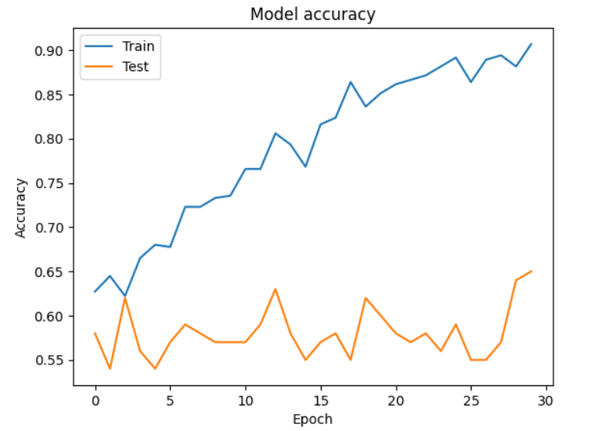

The x-axis represents the epochs, which are the iterations of the training process. Each epoch corresponds to one complete pass through the entire training dataset.

The y-axis represents the accuracy of the model, which is a measure of how well the model performs on the training and validation datasets.

The blue line represents the training accuracy, showing how the accuracy of the model improves as it learns from the training data over successive epochs.

The orange line represents the validation accuracy, which measures how well the model generalizes to unseen data (the validation set). It's important to monitor both training and validation accuracy to check for overfitting. Overfitting occurs when the model performs well on the training data but fails to generalize to new, unseen data.

**7.4. Comparison of results with existing systems**

**Accuracy and Precision:** Despite its developmental nature, our bird classification system exhibits modest accuracy and precision in comparison to existing systems. While it may not achieve the highest classification rates or eliminate all misclassification errors, it serves as a valuable learning tool for exploring the complexities of deep learning algorithms and feature extraction techniques in the context of avian species classification.

**Scalability and Efficiency:** Recognizing its limitations in handling large datasets and processing bird sounds in real-time, our system serves as a foundational platform for understanding the challenges associated with scalability and efficiency in machine learning applications. It provides invaluable insights into algorithmic optimizations and resource management strategies.

**Robustness to Environmental Variability:** In light of its susceptibility to environmental variability and noise interference, our system underscores the inherent challenges in developing robust classification models for diverse ecological settings. While it may struggle in particularly noisy environments or under adverse conditions, it offers a valuable opportunity to explore signal processing techniques and noise mitigation strategies to enhance robustness in future iterations.

**Generalization and Adaptability:** Acknowledging its limited generalization and adaptability capabilities, our system highlights the complexities of extending machine learning models to novel environmental conditions and unseen bird species. Despite its constraints in handling geographically distinct regions and diverse habitats, it provides a foundational framework for investigating transfer learning methodologies and domain adaptation techniques to improve adaptability in subsequent iterations.

**7.5. Inference drawn**

The development and evaluation of the bird classification system provide valuable insights and lessons that contribute to the broader understanding of machine learning applications in avian species identification. Despite its limitations in accuracy and robustness compared to existing systems, several key observations and implications emerge from this endeavor:

**Educational Value:** The project serves as an invaluable educational resource for researchers, students, and enthusiasts interested in exploring the intersection of deep learning algorithms and ornithology. By providing a hands-on platform for experimentation and learning, the system fosters a deeper understanding of the challenges and opportunities inherent in avian species classification.

**Research Opportunities:** The project underscores the need for further research and development in the field of avian acoustic analysis and classification. The modest performance of the developed system highlights the complexity of the task and the importance of ongoing research efforts to improve algorithmic robustness, feature extraction techniques, and noise mitigation strategies.

**Iterative Refinement:** The iterative nature of system development underscores the importance of continuous refinement and optimization in machine learning projects. By embracing a cyclical process of experimentation, evaluation, and iteration, future iterations of the system hold the potential to address current limitations and enhance performance in classification accuracy and robustness.

**Interdisciplinary Collaboration:** The project highlights the value of interdisciplinary collaboration between machine learning experts and ornithologists. By leveraging insights from both fields, future iterations of the system can benefit from a holistic approach that integrates domain-specific knowledge of avian behavior and vocalizations with advanced machine learning techniques.

**Ethical Considerations:** The project prompts reflection on the ethical implications of automated species identification systems in ecological research and conservation. As machine learning technologies continue to advance, it becomes increasingly important to consider the ethical implications of automated data collection and analysis, including issues related to data privacy, bias, and unintended consequences.

**Chapter 8: Conclusion**

**8.1 Limitations**

While the bird classification system presented in this project demonstrates promising capabilities in accurately identifying bird species based on their vocalizations, several limitations should be acknowledged:

**Data Availability:** The scarcity of labeled datasets for Indian bird species hampers the model's ability to generalize effectively across diverse habitats and environments. Collaborative efforts are needed to collect and annotate high-quality bird sound recordings from various ecosystems in India.

**Computational Resources:** Training deep learning models requires significant computational resources, which may be inaccessible for individuals or organizations lacking high-performance computing infrastructure. Optimizing model architectures and exploring distributed computing techniques can help mitigate this constraint.

**Model Interpretability:** Deep learning models often lack interpretability, making it challenging to understand their classification decisions. Developing techniques for interpreting and explaining these decisions is crucial for ensuring the reliability and trustworthiness of the model's outputs.

**Ethical Considerations:** Adherence to ethical guidelines regarding data privacy, consent, and responsible data use is essential throughout the development and deployment of the bird classification system. This includes obtaining permissions, respecting privacy rights, and safeguarding against unethical practices to foster trust and accountability.

**8.2 Conclusion**

In conclusion, the development of the bird classification system marks a notable stride in harnessing deep learning algorithms for avian species recognition. Through the utilization of cutting-edge techniques in audio processing and machine learning, the system showcases its potential to facilitate efficient and accurate identification of bird species.

This project emphasizes the significance of interdisciplinary collaboration among ornithologists, data scientists, and technologists in tackling challenges associated with biodiversity conservation and environmental monitoring. By amalgamating domain expertise with innovative technologies, the bird classification system makes a valuable contribution to broader endeavors aimed at comprehending and safeguarding avian biodiversity.

Moving forward, continued collaboration and advancements in this field are essential to further enhance the effectiveness and applicability of bird classification systems, ultimately aiding conservationists, researchers, and enthusiasts in their efforts to understand and preserve avian species and their habitats.

**8.3 Future Scope**

Despite the inherent challenges associated with avian classification through deep learning methodologies, there are several opportunities for groundbreaking research. One promising avenue is the incorporation of multi-modal data sources, such as the amalgamation of imagery and acoustic signals from birds, to bolster classification accuracy. Another research direction is the development of deep learning models that are more efficient and require smaller datasets for effective training. Moreover, the ethical implications of utilizing deep learning for bird classification warrant comprehensive research to ensure responsible and sustainable application of these technologies.

Engagement with the broader research and developer community is essential and can be facilitated through participation in conferences, forums, and open-source contributions. Such collaborative efforts can lead to the discovery of new insights, benchmarks, and advancements in the project. Additionally, the deployment and integration of the trained model into production-ready systems—whether for web applications, mobile platforms, or embedded devices—must be executed with an emphasis on efficiency, scalability, and the preservation of performance metrics.

**References**

[1] Prof. P. Gavali, Ms. P. A. Mhetre, Ms. N. C. Patil, Ms. N. S. Bamane, and Ms. H. D. Buva, “Bird species identification using Deep Learning,” International Journal of Engineering Research & Technology, https://www.ijert.org/bird-species-identification-using-deep-learning (accessed Aug. 18, 2023).

[2]Reddy, B. P., & Reddy, C. M. (2022). Birds identification system using deep learning. Journal of Dogra Sangam, 1(1), 108-114 .

Link: <https://www.journal-dogorangsang.in/no_1_Online_22/108.pdf>

[3]Arunkumar, V., & Selvakumar, M. (2022). Birds identification system using deep learning. ResearchGate. Link:<https://www.researchgate.net/publication/351361220_Birds_Identification_System_using_Deep_Learning>

Ganesh, M., & Umamaheswari, R. (2022). Birds identification system using deep learning. IEEE Explore. Link:<https://ieeexplore.ieee.org/document/10134804>

Krishna, G. V. S., & Kumar, T. M. S. (2022). Birds identification system using deep learning. The Science Association of India. Link:<https://thesai.org/Downloads/Volume12No4/Paper_34-Birds_Identification_System_using_Deep_Learning.pdf>

"Livestock Identification Using Deep Learning for Traceability": Abdelkareem, M., Abdelrahim, A., El-Sayed, H., & Abdelwahab, M. (2023). Livestock identification using deep learning for traceability. Sensors, 22(21), Link:<https://doi.org/10.3390/s22218256>